**Lab05: A simple servlet that will be needed in the final project (web portion of my final project)**

**PROJECT Name: OnlineBookRentalSystem**

***SujitaPokharel_14105ps***

***CS532A***

***Fall 2015***

**Abstract:**

This is web portion of my project. I have tried to simulate a part of library management system. This project deals with the online book renting maximum for a semester (i.e. 3 months). I haven’t included the login and logout part. I have designed only the part from welcome page after login to the book checkout phase. Since this is just start of the project, all the functionalities might not be functional as expected. I will work on those parts later.

**Brief Description of Project:**

* There are five servlets to handle five jsp pages.
* From Welcome/ home page we can view the list of books
* The available books can be added to cart
* The unavailable books are marked as ‘unavailable’ on red color
* We can go back to add book or we can proceed to checkout after adding one book to cart
* We need to select the duration for renting book (1, 2, or 3 months only)
* Then after clicking continues we will move to next page which displays the books we have rented along with the duration and other messages.

**ScreenShot:**

**Running the Web Project:**

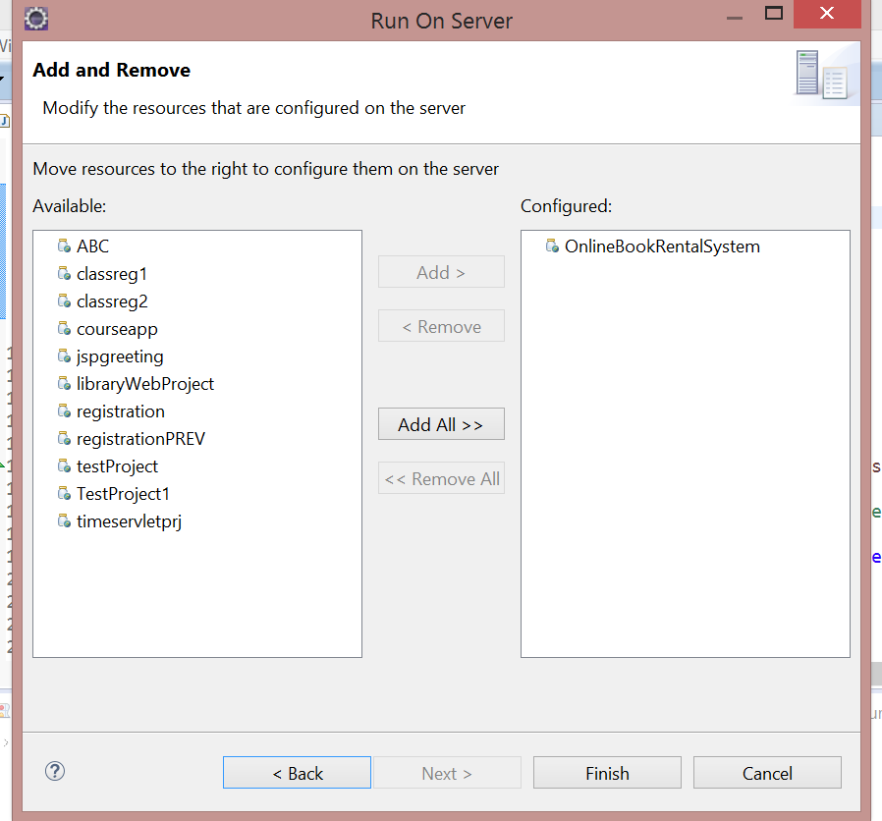

Welcome page/ home page (first page of web application , handled by first servlet)

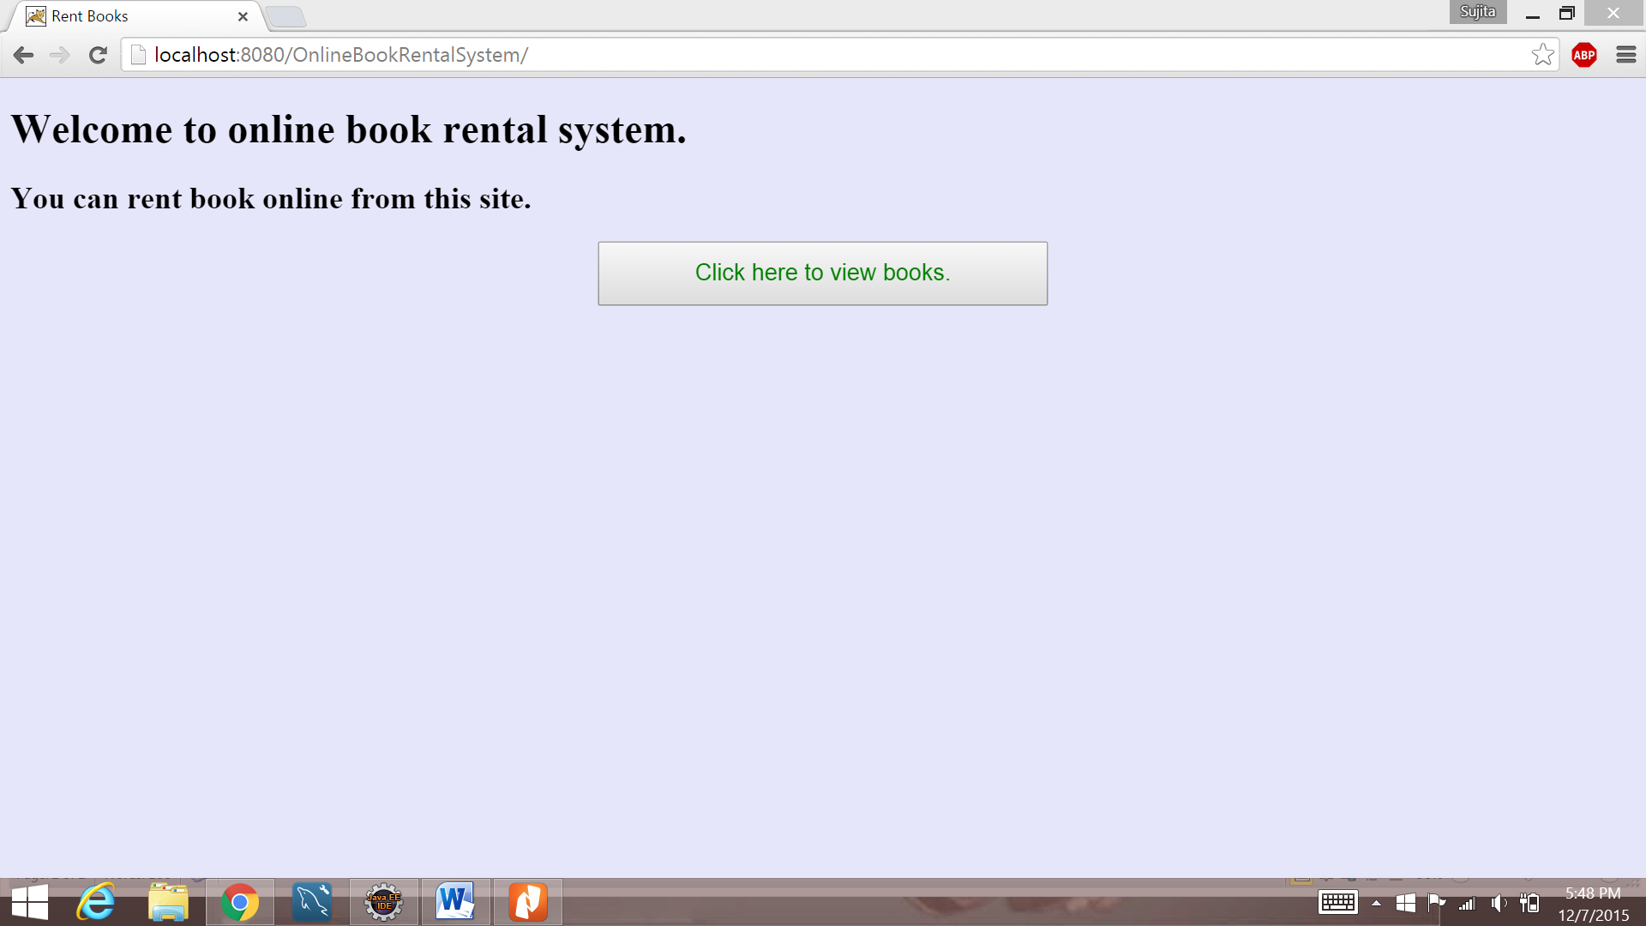

Second page (handled by second servlet), Algorithm Book is out of Stock

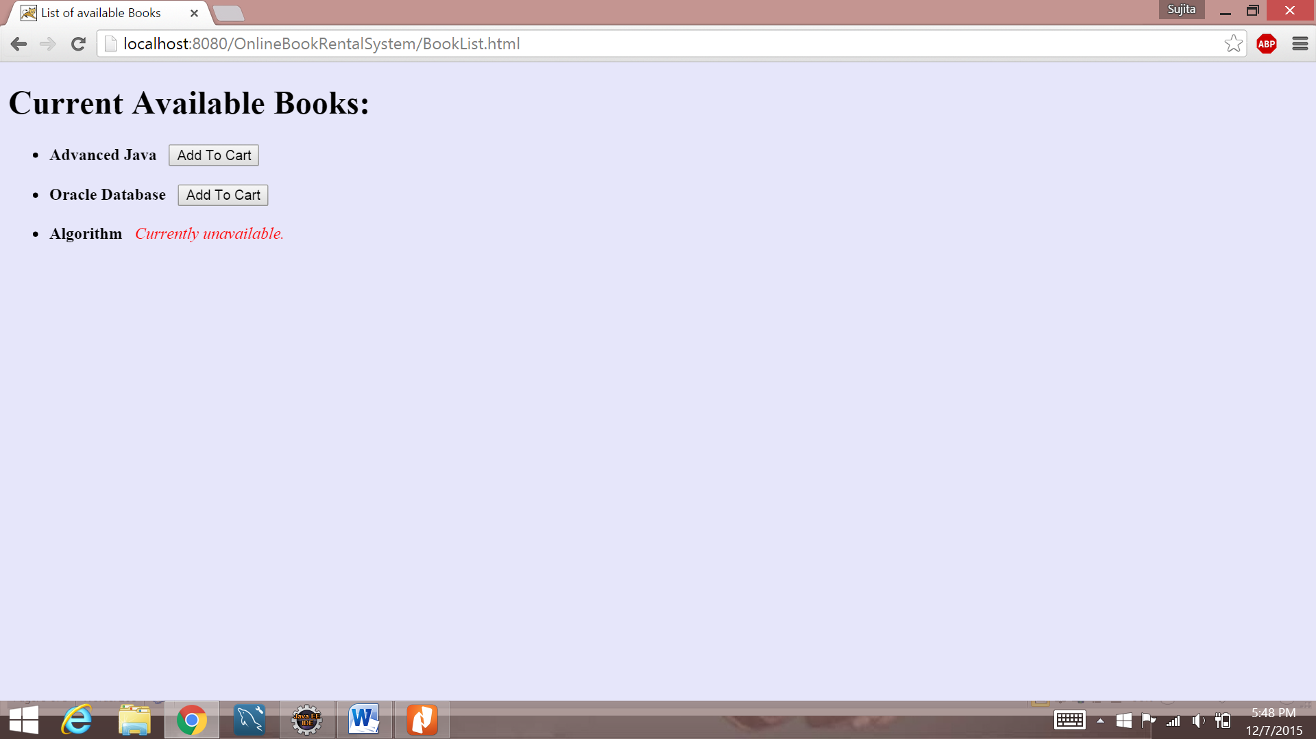

Third page (handled by third servlet, can add more books or proceed to check out)

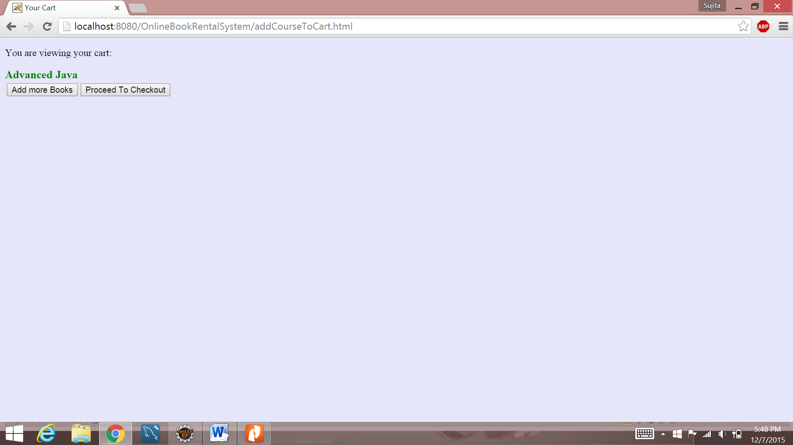

Added more books so redirected to the second page by third servlet

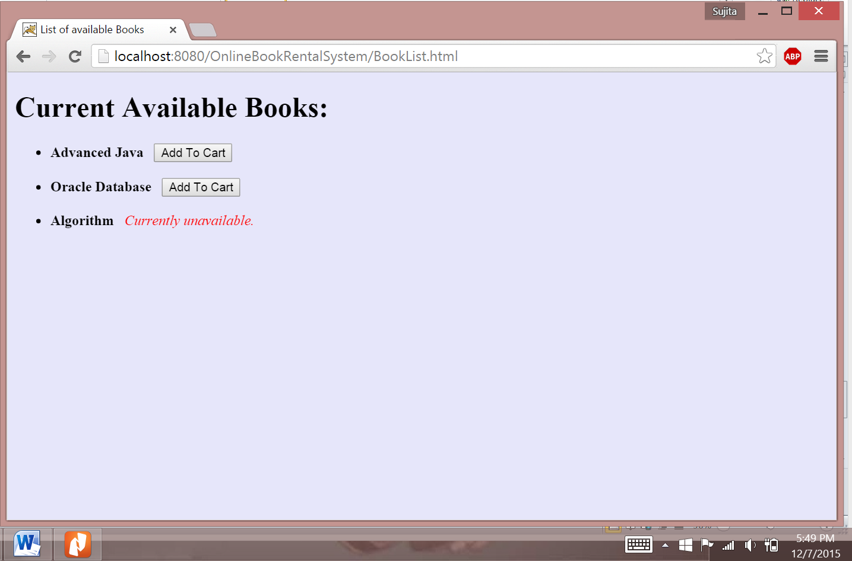

Added second book

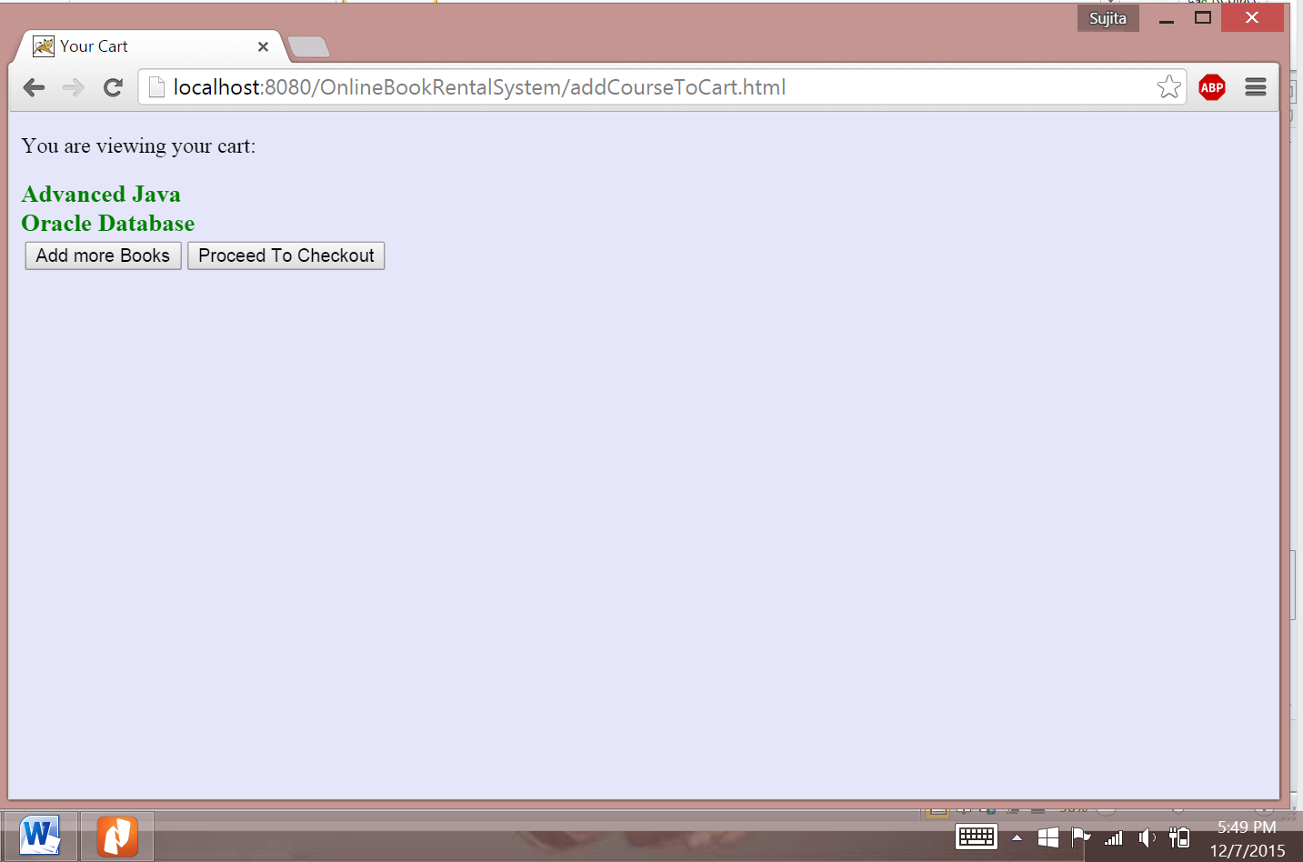

Same Books won’t be added twice:



Hence the number of books are two:

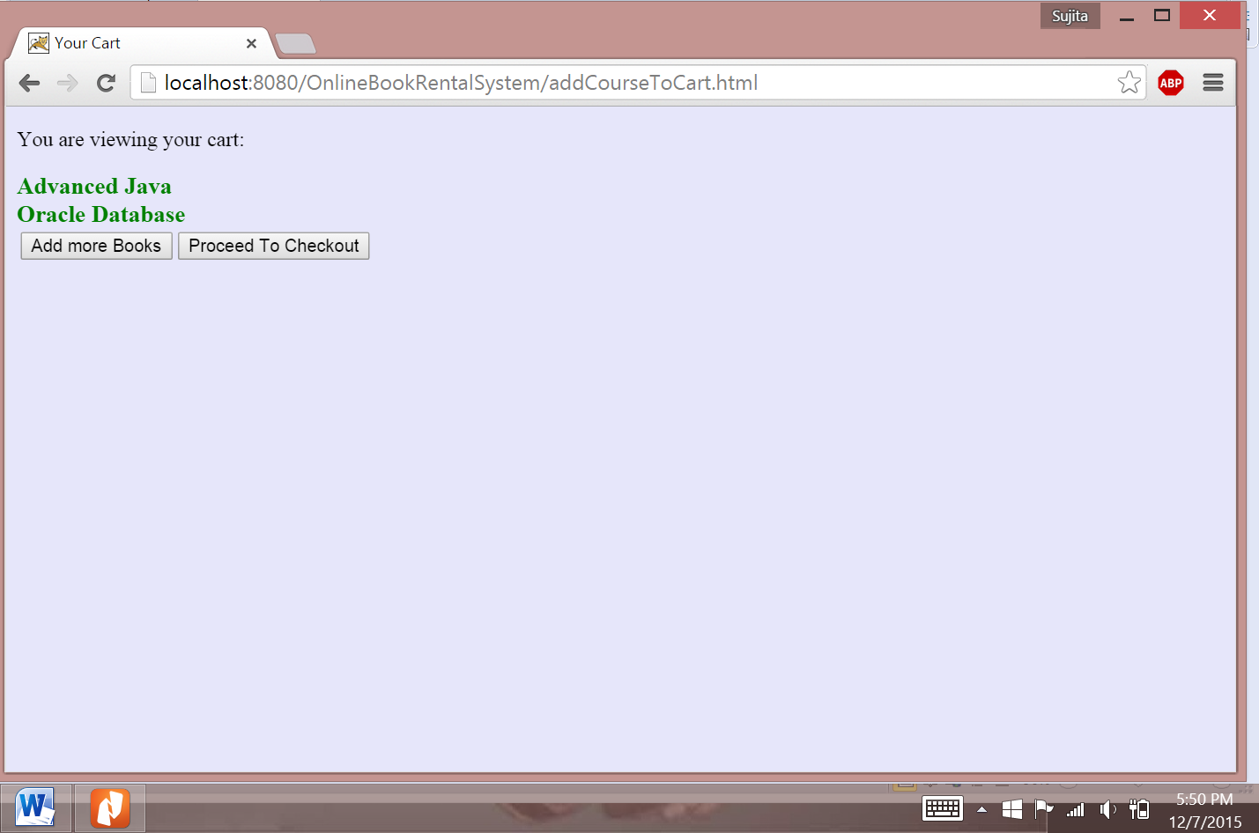

Fourth page ( ask for the duration , and displays the total no of books user wants to checkout), handled by fourth servlet

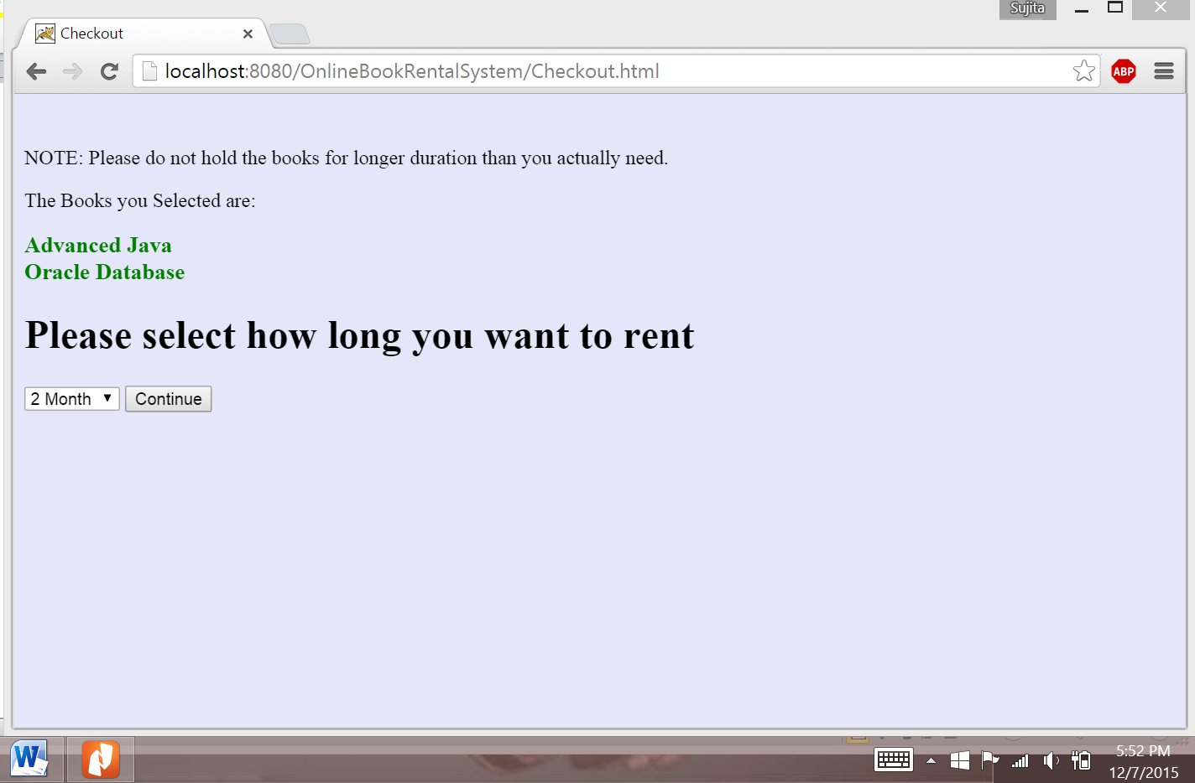

Last page (handled by fifth servlet, will display successful message and the duration user can access the book)

